Notes for running the CRS Eye Tracking Analysis Toolkit.

Requirements

Matlab R14 SP3 or greater

Converting the raw data

The CRS Eye Tracking Analysis Toolkit (ETAT) analyses eye tracking data files produced by the CRS Eye Tracker Software

The CRS Eye Tracker software is used to calibrate the CRS Eye Tracker and capture the raw data produced by the eye tracker.

In order to use the CRS Eye Tracking Analysis Toolkit you will need to have the calibration file from the Eye Tracker – this is a standard Matlab file and the raw output from the eye tracker – this file is generated from the Matlab Data Acquisition Toolbox and will have the extension .daq.

For each run you will need to have the corresponding calibration and daq file as well as design files which describe the course of the experiment. The structure of the design files is described later in this document.

Run Matlab and browse to the directory where you have copied the toolkit.

To run the toolkit enter the command etatcrs.

The toolkit main window will appear:

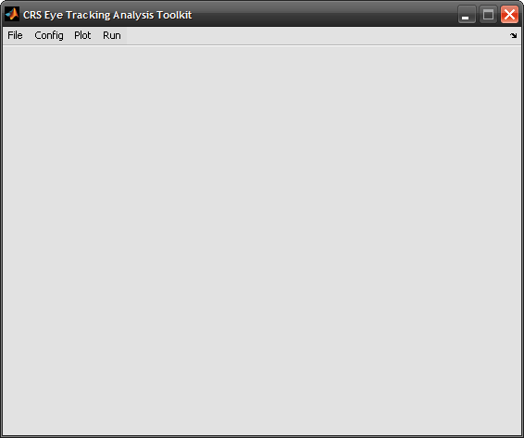
Figure 1 Main toolkit window

Plotting data using the toolkit

You can plot the raw data from the Plot menu,

To plot the raw positional data choose Plot Positional Data. The software will ask you to specify the .daq file containing the data and the corresponding calibration file.

Once you have chosen which file to use the software will then ask you how you want to process the raw data.

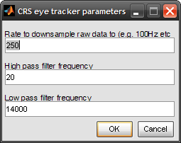
Figure 2 CRS Eye Tracker Parameters

Here you can specify to down-sample the raw data to a specific sample rate. The CRS Eye Tracker software records at 1000Hz which generates very large data sets. By down-sampling the data you can make the processing faster – particularly for very long sessions. It is recommended to down-sample to a rate which gives a whole number of milliseconds between each reading – e.g. 500Hz, 250Hz or 200Hz etc.

You can also choose to filter the data using high and low pass filters. It is recommended to keep the values as they are displayed.

Once you select OK, the software will load the raw data file and convert the voltage data into a position in degrees.

The CRS Eye Tracker software only captures the x coordinate of the position of the eye so only horizontal position is processed.

A run of data starts when the eye tracker was triggered to start and ends when the eye tracker was triggered to end. For the most part a run will correspond to a line in the protocol sheet or a single run of the experiment.

Using the CRS Eye Tracker Toolkit you will only be able to review the data from one run at a time.

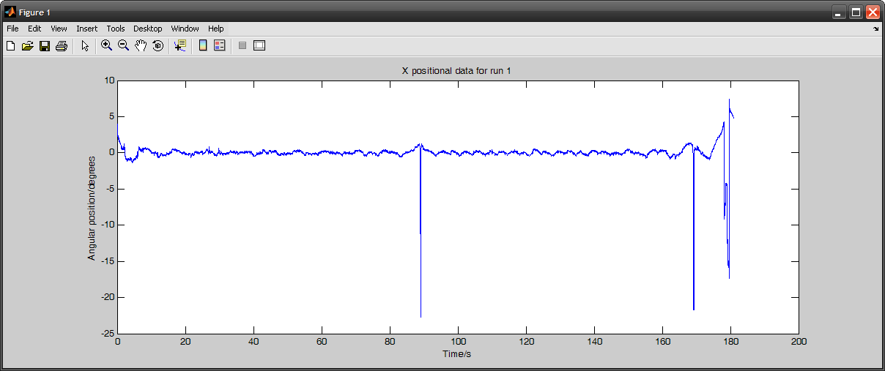
Figure 3 Position plot of a single run of data

You can use the standard Matlab tools to move around the data if you wish.

Once you have got an overview of what the raw data looks like you can also use the other items on the Plot menu to plot velocity or to view smaller subsections of the data. These options operate in the same way.

Analysing a single subject

To analyse a single subject choose Run Full Analysis for a Single Session from the Run menu.

The firs thing the software will ask you is how many conditions are present in the data.

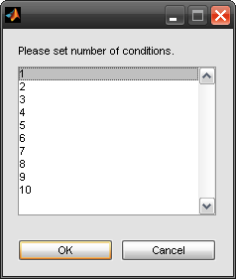
Figure 4 Select number of conditions

Choose the number of conditions as per your experiment; you need to include fixation as a condition here; and then choose OK.

The toolkit will then ask you to provide names for each condition which you should enter appropriate to your own experiment. You should also identify the starting value for your conditions – this will usually be the fixation condition and is likely to be 0 or 1. You should tick the box on the right hand side of the dialog to identify which condition is your fixation.

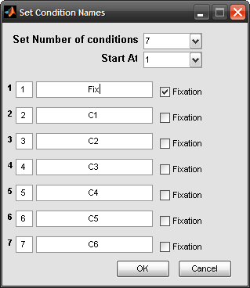
Figure 5 Specify conditions

Having specified the number of conditions the software will ask you how many data files should be analysed. For each data file you should have the raw data, a calibration file and a design file.

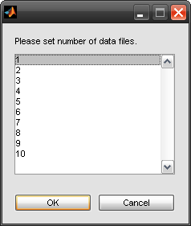
Figure 6 Set number of data files

The format of the design file is a text file with the .txt extension and is structured as follows.

The first column will always consist of a list of the conditions in the order the stimuli were presented. Any time corresponding to fixation should also be included.

For example

0
1
3
2
4
5
0

Here the run consists of an initial fixation followed by blocks of each condition followed by a final fixation. This example does not detail how long each block lasts for or how many trials each block contains. This can be entered at run-time as detailed below.

If each block contains the same number of trials and is the same length then this is all the file should contain.

For experiments where different conditions have different durations (or where the fixation is a different duration from a stimulus block) then the file can also contain the length of a specific trial in milliseconds followed by the number of trials in the block. This should be specified for each condition presented.

For example

0,8000,1
1,500,10
3,500,10
2,500,10
4,500,10
5,500,10
0,8000,1

This would denote initial fixation of 8 seconds followed by blocks of 5 seconds consisting of 10 trials in each block.

It is also possible to have a fourth column in a design file - the presence of this column denotes the actual stimulus time as opposed to the trial time. If this column is present then saccades etc. will be only be detected while the stimulus is displayed.

For example

0,8000,1,8000
1,500,10,300
3,500,10,300
2,500,10,300
4,500,10,300
5,500,10,300
0,8000,1,8000

In this case the stimulus is only present for the first 300 milliseconds of a trial and saccades will only be detected during this period.

Once you have specified the conditions for the experiment the software will present the following screen.

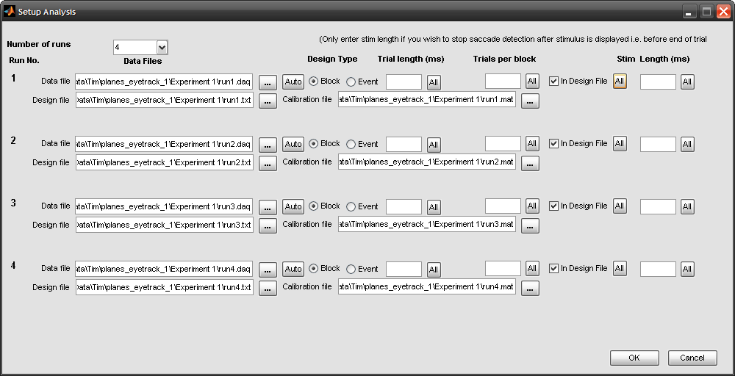
Figure 7 Setup analysis

Here the user has specified that the analysis should contain 4 runs. You can change the number of runs using the appropriate drop-down box.

For each run you must specify the name and path for the data, calibration and design files.

Click on the ellipsis (…) button next to each text box to choose the relevant file. You must have a design file for each run you wish to analyse. It is helpful to name your files according to the run no – e.g. Expt_MPD_Data1.daq, Expt_MPD_Design1.txt and Expt_Data1.mat. If you click on the Auto button next to the data file the software will detect the last number present in the filename and will ask you if you wish to auto-complete the filenames. This can save you a lot of time when setting up the analysis.

Next to the data file is the option to specify that the design is Block or Event-related. You should ensure the appropriate option is selected for you experiment. If you choose Event then the Trials Per Block column will be automatically filled in with 1.

The remaining columns determine how the raw data is broken up.

If your design file contains trial lengths and trial counts etc. then you should check the In Design File option and leave the rest blank otherwise enter the trial length and number of trial per block appropriate to your experiment.

You can also enter a stimulus length here which will cause the software to only detect saccades during the time the stimulus is presented. This option will apply the same stimulus duration to all conditions, whilst if you specify this in the design file you can specify a different stimulus duration to each condition.

The All buttons will replicate the current value to all rows in the table.

Once you have specified all the design configuration parameters, click the OK button. The software will validate that all required information has been entered and that all specified files exist.

The software will then load and verify all the data required for analysis and ask you if you want to see summary information for blinks, saccades and fixations.

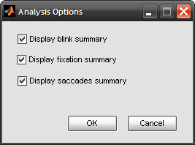
Figure 8 Display summary information

The first time you run an analysis it is recommended that you leave all these checkboxes checked so you can see what your results look like.

Once you have selected OK the software will analyse the data and will attempt to detect and distinguish between blinks and saccades using known relationships between the velocity, duration and amplitude of a saccade.

Most sequences will be categorized automatically however sometimes the software will identify a sequence as a possible saccade and/or blinks but will need confirmation from the user before continuing.

In this case the software will display a plot of the data around the sequence in question as shown below and in the case of a suspected saccade it will present some statistics about how close the sequence is to a model saccade to help you decide.

One of the parameters is the ratio of average velocity to peak velocity – this should be between about 0.5 and 0.75 for the sequence to be a saccade.

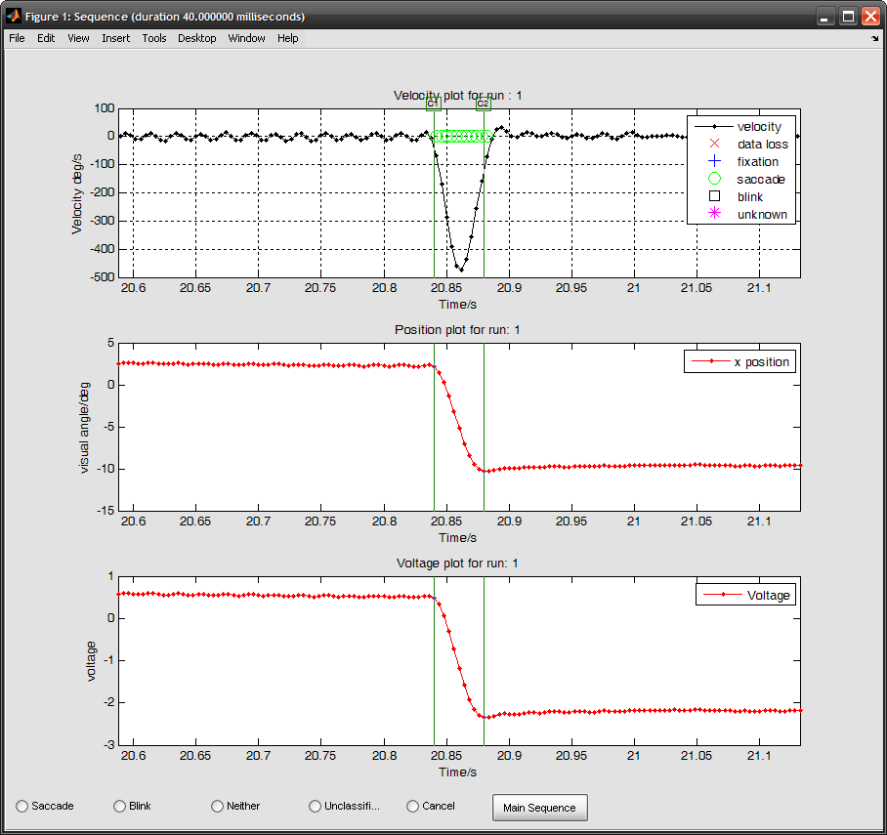
Figure 9 Classifying a sequence of data as a saccade

Here the top chart shows the velocity, the middle the position in degrees and the bottom the raw recorded data in volts.

The sequence in question is delimited by green cursor lines labelled c1 and c2 and the velocity plot is overlaid with symbols representing what the software has classified the sequence as. You can enlarge or reduce the sequence in question by holding the mouse down on the green lines and moving them. At the bottom of the plot are a number of option buttons. You can confirm what the software thinks the sequence is by choosing the appropriate button or you can choose to override the software if appropriate to do so.

In addition by clicking on the button labelled Main Sequence you can display a graphical representation of how close the sequence is to a model saccade.

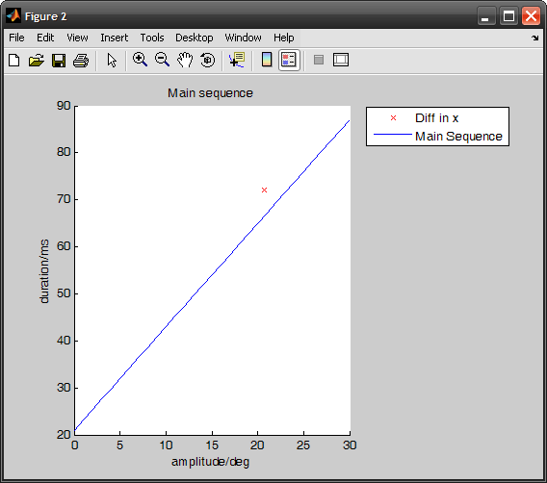
Figure 10 Main sequence approximation

In this plot, the blue line corresponds to the known relationship between amplitude in degrees and duration in milliseconds known as the Main Sequence and the red cross shows how the sequence of data in question approximates it. The close the cross is to the line the more the sequence matches the Main Sequence and the greater the likelihood that the data represents a true saccade.

If you moved the cursor lines in the main window then the Main Sequence plot will show the results based on the duration of the sequence as shown and not the original sequence which was detected.

One word of warning about classifying sequences, the beginning of a blink can look a lot like a saccade however the velocity for a blink is usually much greater than that for a saccade.

Ordinarily the software will identify the blink automatically from its characteristic pattern so so if it is wrongly identified as a saccade the software will compensate for this and reclassify the whole sequence as a blink.

A typical blink sequence is shown below:

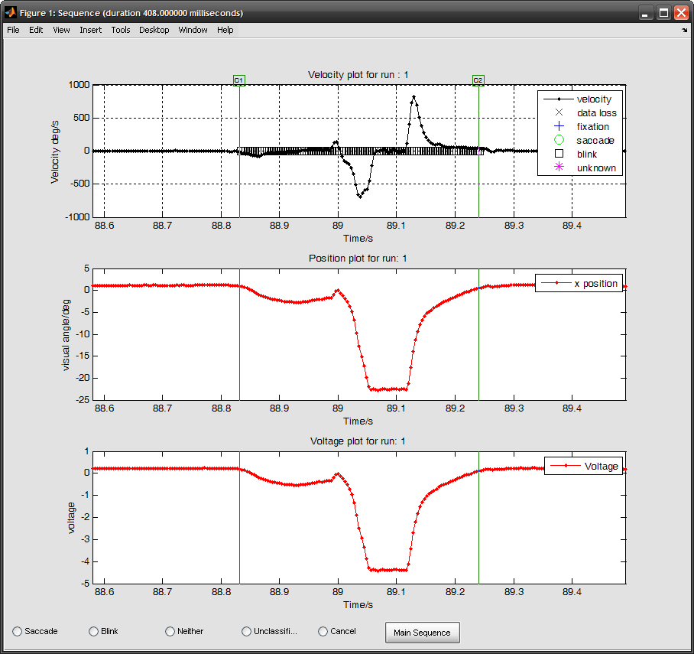
Figure 11 Typical blink sequence

Once the software has analysed the run, if you chose to display blink summary the software will display a chart for each run as below.

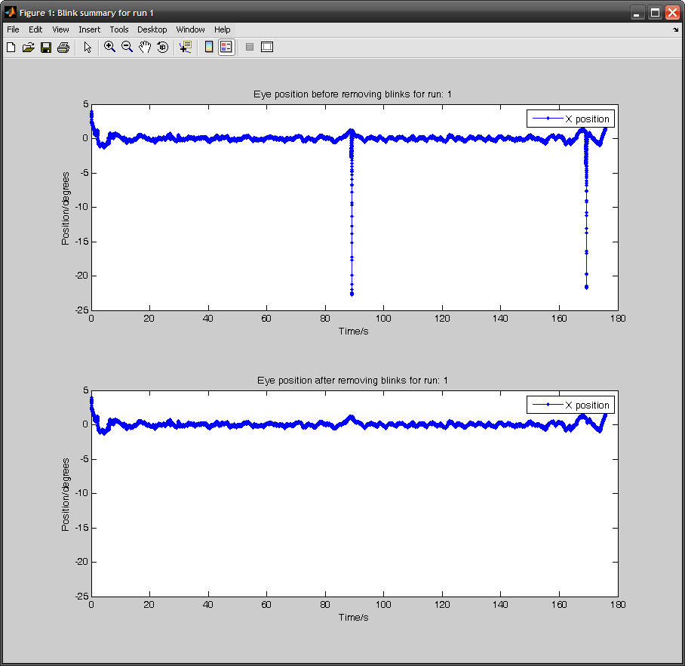
Figure 12 Blink Summary

The top chart shows X position before blink removal. The bottom chart shows the data once blinks have been removed.

As can been seen blinks can appear as large changes in position over a very short time. The position in degrees is not important as no determination of fixation has yet been done so position will not be centred on zero. Once fixation detection and saccade detection has been carried out the software will automatically reposition the data.

To analyse the next run close the window and then next run will be analysed automatically.

Following blink detection, the software will then detect fixation positions – these are periods within the data where the position does not change and correspond to times when the subject is fixating properly..

Once the software has finished detecting fixations and saccades for all runs a summary screen is display as below.

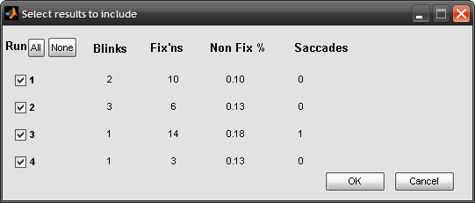
Figure 13 Summary information

Here you can see the number of blinks, fixations and saccades which have been detected.

If one or more runs look like they contain bad data they can be excluded from further analysis by unchecking the relevant box on the left hand side.

Following this summary if you have selected to show a summary of saccades then for each run a chart such as the following will be displayed.

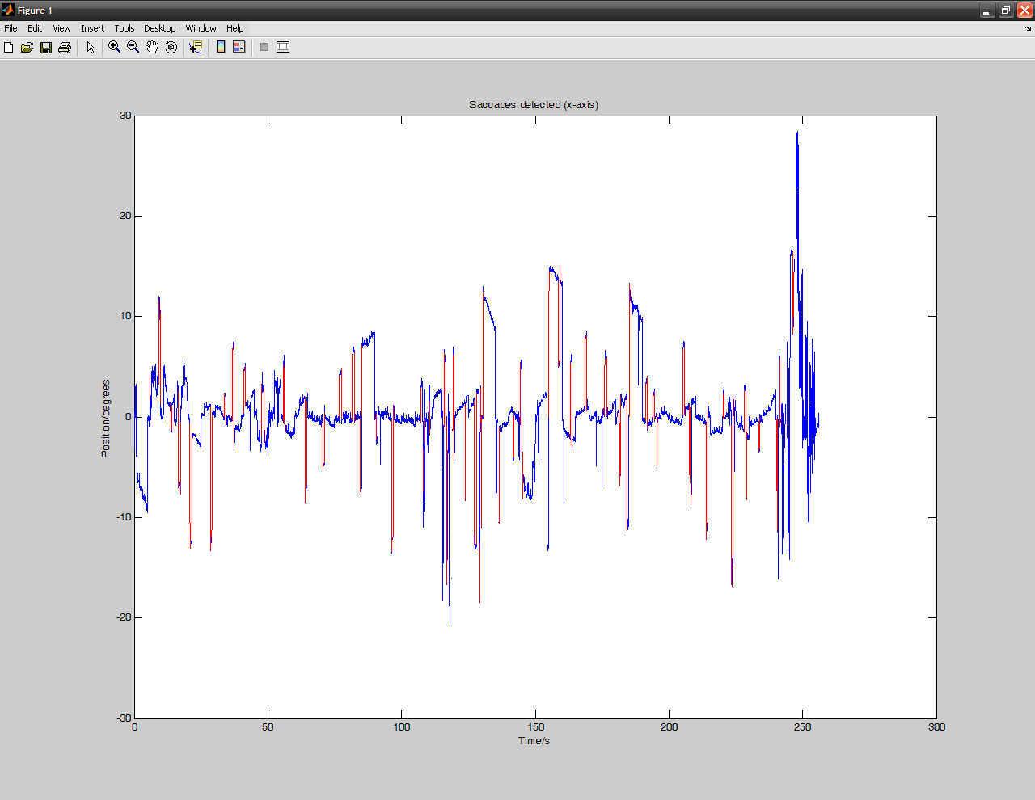
Figure 14 Saccade summary

Here the eye position for the x and y axes are shown in blue with detected saccades overlaid in red. Because the scale is highly compressed it can be useful to zoom on specific areas. Also not every spike in the data will constitute a saccade as the software uses specific parameters of velocity and duration to determine what is and is not a saccade.

Once you have reviewed all the saccade information the software will then display a summary of all the fixations (if you have requested to see it) as follows.

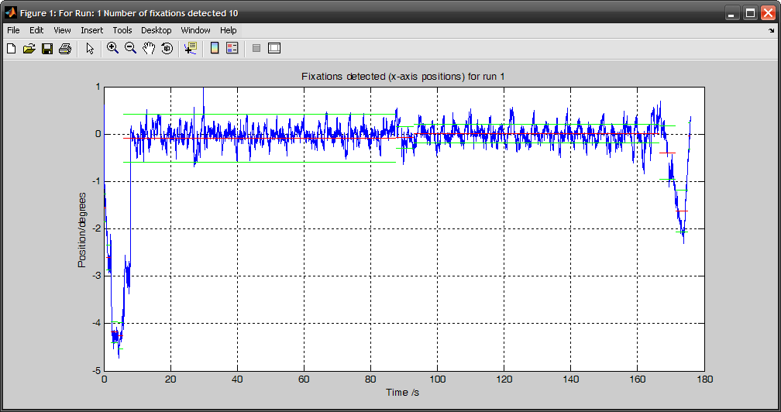
Figure 15 Fixation Summary

Here the corrected eye position is plotted in blue with the detected fixation positions overlaid. Because of the compressed scale it can be difficult to see so a zoomed representation of part of the trace is shown below.

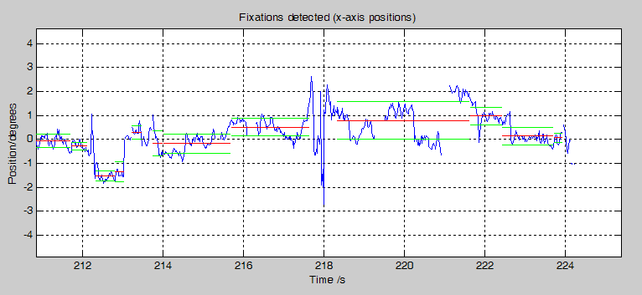
Figure 16 Fixation summary close-up

Here the mean position for each fixation is shown by the red line and the green lines above and below show 1 standard deviation from the mean. In the middle of the trace is a possible saccade. The software detects there is a rapid change in position over time and does not mark that as part of a fixation.

The number of fixations present is shown in the title of the window. A high number of fixations suggests that the data is fairly fractured either because of poor signal or a lot of eye movement. It is important to note that a blink does not necessarily end a fixation, however anything which constitutes loss of signal does.

Once all the summary information has been presented, the software will calculate and display a series of charts summarising the data over all runs broken down by condition as below.

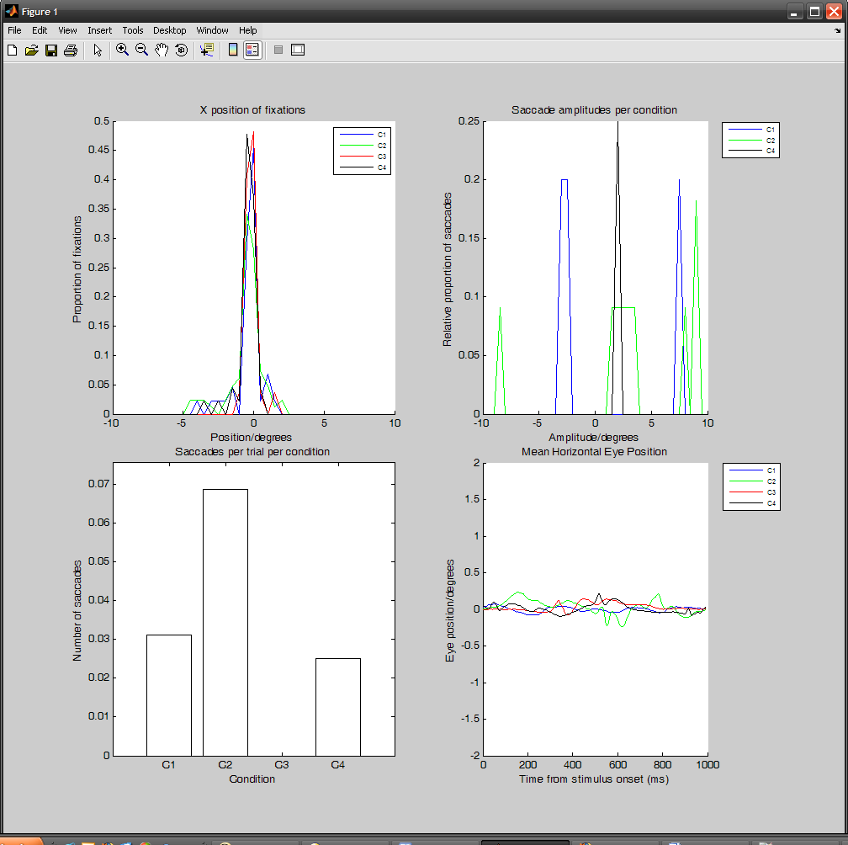
Figure 17 Summary of analysis by condition

The first chart shows the distribution of fixation positions over all runs for all conditions for the x axis. The peak of the fixation charts should be centered at 0 showing that the eye position is mostly at the fixation.

The second two charts shows a summary of the saccades which were detected. The first chart shows the distribution of saccadic amplitudes per condition; the minimum amplitude being 2 degrees visual angle. The second chart shows the actual count of the number of saccades detected per trial per condition over the sequence of runs.

On the final line is the mean horizontal eye position calculated for each trial separated by condition.

If the design setup specified a specific stimulus length a second chart is drawn next to the first which shows the horizontal eye position over just the stimulus duration.

It is important to note that the fixation condition is not plotted here as there is usually much more variation for the fixation than there is for actual stimulus conditions – it is also not really relevant as the presentation of the fixation is not actually a stimulus.

You can save the summary chart in any format you wish using the standard commands on the File menu of the chart. Once the chart is closed the software will ask if you want to save the data to a file. This is a standard Matlab .mat file which will contain everything from the raw data to the summary information and is structured as follows:

All the data is contained in a single nested structured called EyeData.

Within the EyeData structure are the following top level variables

designData | Contains details of the design of each run
segment | Structure containing all the processed data for each individual run
samplesPerTrialPerCond | Number of data samples per trial per condition
stimLengthPerCond | Stimulus length per condition
trialLengthPerCond | Trial length per condition
trialPerCondition | Number of trials per condition
saccades | structure containing details of the saccades which were detected
saccSummary | structure containing details from which the saccade summary charts are produced.
fixSummary | structure containing details from which the fixation summary charts are produced
fixationsPerCondition | structure containing details of fixations per condition
eyePositions | structure containing details from which the mean horizontal eye position chart is produced.

The designData structure is populated as follows for each run which is analysed

realSegmentIndex | Actual segment no. in the raw data corresponding to a specific segment
designFile | Full path to the respective design file for the run
dataFile | Full path to the data file for the run
calibFile | Full path to the calibration file for the run
designType | For block designs this will be ‘B’ for event designs this will be ‘E’
trialLength | ”Default” trial length for this run
numTrials | Number of trials
trialParamsFromDesign | Denotes whether the trial length etc. was entered at run-time or was provided from the design file
stimLength | Stimulus duration – will be the same as trialLength if not supplied
blockConditions | Condition of each block (for event design will be the condition for each trial)
trialLengths | Trial lengths for each block/event
numTrialsPerBlock | Number of trials per block
stimLengths | Stimulus durations per block

For each run the segment structure contains the following data

voltageData | Raw voltage data as output from the eye tracker
numRecords | Total number of records in the raw data
startTime | Actual start time of the recording from the raw data (always 0 for the CRS Eye Tracker)
endTime | Actual end time of the recording from the raw data
duration | Total time in seconds for the duration of the recording
recordNo | Record number for each sample for the duration of the recording
sampleTime | Actual time in seconds that each sample was recorded relative to the start of the recording.
origAngleX | X and Y position in degrees visual angle without calculated fixation.
angleX | X and Y positions in degrees visual angle adjusted to centre around fixation.
tagType | For each sample in the data the software records whether the position was part of a blink,saccade or loss or fixation – will contain ‘B’,’S’,’L’,F’ respectively. If the software did not classify a specific position it will contain an ‘N’.
trialsPerCondition | contains the start and end indices of data samples which delimit each trial in a specific condition
sampleDiff | mean difference in sample time between samples in milliseconds
totalSamples | Total meaningful number of samples (based on design parameters, the data is truncated at the point where the end point of the last trial in a run is determined to be)
condition | For each sample in the data the specific condition is calculated based on the design data.
blinkCount | Number of blinks detected in a run
nonFixPct | Percentage of data in a run which is not considered to be fixation
fixations | Structure containing details of each fixation detected (start,end indices, mean and std deviations of position over the fixation and the duration of the fixation)
fixCount | Number of fixations detected in a run
velX | Estimated instantaneous velocity of movement over time for each sample in the data
velTime | Time point for velocity between individual samples
saccCount | Number of saccades detected in a run
include | The value 1 determines if a run should be included in the analysis, 0 means it is excluded from further processing.

The saccades structure contains details of each saccade detected per condition as follows:

Count | Number of saccades detected per condition
Saccade | Structure containing start and endpoints, duration and amplitudes for each saccade

The saccSummary structure contains details which are used to produce the final saccade charts:

amplitudeData | Contains proportions of saccades at different amplitudes for each condition. Data is binned by amplitude from -10 to +10 degrees every 0.5 degrees.
saccCounts | Array containing number of saccades per trial per condition

The fixSummary structure contains details which are used to produce the final fixation charts.

positionData | Structure contains the proportions of mean X positions of fixation per condition. The data is binned by position from fixation from -10 to +10 degrees every 0.5 degrees
.

The fixationsPerCondition structure contains details of each fixation detected broken down by condition.

meanX | Mean position of fixation
stdX | Standard deviation of position of fixation

The eyePositions structure contains details used to plot the mean eye position charts.

meanXPerCondition | contains a variable xPos which gives the mean horizontal eye position over all trials broken down by condition

Analysing group data

To analyse data from more than 1 subject choose the Run Full Analysis for multiple subjects option from the run menu.

The process is very similar to running analysis on one subject except that you can must specify how many sessions to analyze.

Once you have entered design information for all sessions you wish to analyse the software will perform the same analysis as on a single file but for all files which were selected.

For multiple session analysis the option to display summary graphs of fixations etc. is not provided, however the software will still ask you to classify unknown sequences interactively.

Once the analysis is complete the software will display summary tables of fixations, saccades and blinks as with analysing a single file. A table will be displayed for each subject separately with the option to exclude certain runs from the analysis if so required.

Finally the overall results will be displayed on a series of charts as with a single subject. The only difference being that the graph of saccades per trial per condition will also show error bars.

You can again save these charts in any format Matlab allows using standard Matlab procedures.

Once you close the figure you are given the option of saving the entire set of group data to a single Matlab file.

The file format for the group data is as follows

The top level variable is called groupData

Below this the following structure exists

session | Contains details of each individual session which was analysed
eyePositions | Contains the same data as for a single subject
fixSummary | Contains the same data as for a single subject
saccSummary | Contains the same data as for a single subject but includes also includes details of the standard error.
saccades | Contains the sum of the total number of saccades per trial per condition over all sessions

The session structure contains an EyeData structure for each session and a further structure call ASLFile.

The EyeData structure contains details the same information as with a single subject as described above.

The ASLFile structure details information about the file associated with a given session as follows.

fullfile | Fully qualified path for the data file for a given session
file | Filename only for the data file for a given session
segmentCount | Number of runs in a given session
exclude | Exclude this session in analysis

You can extract the data from the individual and group data files to perform statistics on the results.

